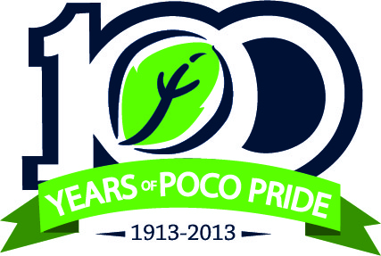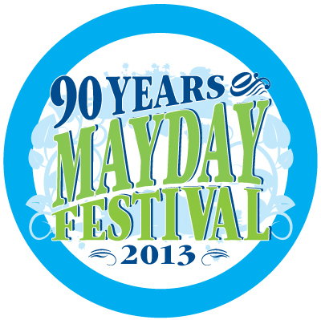

PORT COQUITLAM CELEBRATES MAY DAY 2013

May 3 - 12, 2013

Join the City of Port Coquitlam and help the community spirit come alive by participating in the May Day festivities. In addition to celebrating 90 years of May Day celebrations, Port Coquitlam is also celebrating its 100th birthday. This is an extra special year, with a blend of traditional May Day festivities and new events in recognition of 100 years of PoCo Pride. For additional birthday information, please visit www.portcoquitlam.ca/100!

We are inviting your school to take part in either the traditional May Pole Dance and/or by encouraging individual students to be a part of the May Day Royal Party.

The May Pole Dance has been a tradition in Port Coquitlam for 90 years and is performed by local school children during the May Day Opening Ceremony which is being held on May 3, 2013. Students are always enthusiastic to join and a commitment from a minimum of 22 students from each school is required. A volunteer May Pole Coordinator is available to support teachers or parent volunteers during practices which we recommend you hold twice a week beginning in late January. Once schools have confirmed their interest, the dance music, ribbons and pole will be delivered to your school.

The Royal Party consists of Flower Girls from Grades 1 and 2 and Princesses and Lancers from Grades 4 and 5. Students interested are asked to apply on-line at www.portcoquitlam.ca/mayday. Please contact Shelly Alford at RoyalParty@portcoquitlam.ca if you require more information or if you would like to recommend a student that you believe would benefit from being part of this experience. The application deadline is Monday, February 4, 2013.

Royal Party participants will be randomly selected from all interested applicants. The selected participants will be required to attend dance practices on Friday afternoons (Grades 1 & 2 from 4-4:40pm and Grades 4 & 5 from 4:45-5:30pm) from February through to April. They also will be asked to attend the May Day Opening Ceremony on May 3, 2013 and the May Day Parade on May 11, 2013. A more detailed list of Royal Party responsibilities will be provided upon selection of interested participants. A parent information evening will be held on February 12, 2013.

I look forward to having your school become involved in this historical community event!

Yours truly,

Shelly Alford
Program Coordinator – Health and Wellness

cc. Sandy Battle, Program Coordinator – Community and Civic Events
Shawn Fengler, Recreation Program Assistant - Sports

